St Joseph’s Catholic Primary School, Malmesbury
Feedback and Marking Policy

“Walking in the footsteps of Jesus, loving and serving together”
Mark for Impact

A highly effective, evidence based feedback strategy

RATIONALE
St Joseph’s Catholic Primary School has adopted the ‘Mark for Impact’ strategy to ensure that all pupils have their work responded to in such a way that it is meaningful, manageable and motivating with a clear view to rapidly improving learning, developing pupil self-confidence and raising self-esteem. Pupils in receipt of the Pupil Premium Grant (PPG) are prioritised to ensure an equitable approach as part of our Pupil Premium strategy.
Each element of the Mark for Impact strategy (Pupil Conferencing, Class Conferencing and Learning Steps) brings together threads of evidence based, successful teaching practice to create a high impact approach to effective feedback. Mark for Impact supports the principles and practice of high quality teaching and fully aligns with recommendations for the EEF tiered approach to improve pupil outcomes alongside published guidance for effective feedback.
At St Joseph’s Catholic Primary School, we believe that the most effective feedback happens through discussion and personalised approaches and this can take place in a variety of different ways including 1:1, group or whole class discussion and feedback sessions. Our strategy places an emphasis on all teachers regularly engaging with pupils in a discussion based manner and is based on a combination of Pupil Conferencing and Class Conferencing opportunities, underpinned by Learning Steps. More traditional written marking and feedback still has a place at points where a focus on individual next steps are being reviewed.
All feedback at St Joseph’s Catholic Primary School will:
  - Positively and rapidly move learning forwards
  - Be clear, meaningful and precise
  - Be consistent
  - Inspire and motivate pupils to improve their learning
  - Follow the Mark for Impact strategy

AIMS AND OBJECTIVES
- Pupils are regularly given effective feedback, verbal and/or written, in order to move their learning forward.
- Teacher time is used effectively for maximum impact on pupil progress and attainment while reducing workload;
- All pupils know how to improve, through use of Learning Steps and Pupil/Class Conferencing opportunities, and are actively involved in reflecting upon their learning.
- A clear, supportive dialogue between adults and pupils is visible within lessons, in books, during meetings and evidenced in recordings on Pupil/Class Conferencing templates.
- Pupils are regularly inspired by the good practice of their peers and through modelled examples which they reflect on during Class Conferencing sessions;
- Learning is put into context with real life models of success/misconceptions being meaningfully pupil led;
- Feedback is often discussion based (either whole class, group or individual) and effectively communicates next steps through a positive dialogue with the teacher;
- In Class Conferencing, teachers are able to address areas that will quickly move the learning of the whole class forward while supporting pupils individually with deep marking and Pupil Conferencing sessions;
- Pupils are able to quickly see progress through achievement of Learning Steps;

The St Joseph’s catholic primary School model for effective feedback
The following table outlines the structure of our combination approach to high quality, effective feedback.

CONFERENCING
PUPIL CONFERENCING | CLASS CONFERENCING
- Weekly 1:1 sessions between class teacher and pupil and/or group for 1 hour a week;  - Teacher uses Pupil Conferencing template to record discussion, evidence specific feedback areas for individual pupils and identify pupils who have attended sessions;  - Focus is on a collaborative discussion regarding strengths and positive progress, misconceptions, review of progress towards achievement of Learning Steps, targeted support for securing a detailed aspect of learning (e.g. column subtraction, apostrophes);  - Reinforces the school’s general high expectations for presentation, handwriting and spelling;  - Further develops a positive teacher/pupil relationship and boosts confidence. | - At regular key points in an English unit (Writing) and, as appropriate, for Maths and other curriculum areas;  - Teacher uses Class Conferencing template as a tool to support discussion and provide quality feedback on progress towards the objective(s);  - Reflects on achievement of LO, whole class strengths, misconceptions, individual achievement, next steps and progress towards Learning Steps;  - Frequently uses examples of pupil’s work to model achievement, misconceptions etc;  - Reinforces the school’s general high expectations for presentation, handwriting and spelling;  - Identifies focus group/individuals that the teacher will be working with during next steps;  - Requires pupils to regularly reflect on progress towards class and individual Learning Steps.
LEARNING STEPS
- Learning Steps underpin the conferencing strategy for securing, and celebrating, pupil progress and achievement in Writing - grammar and punctuation, handwriting and spelling (HFW and common exception words);
- The menu of Learning Steps is used diagnostically to identify whole class/group/individual gaps in learning which teachers can then plan to address with rapid impact on pupil progress;
- Learning Steps are then used as a skills menu for planning, teaching and targeted support in writing, including giving feedback through Class Conferencing;
- Achievement of Learning Steps is regularly monitored, providing evidence of whole class and individual progress over time.
- Pupils in receipt of the PPG, and other vulnerable pupils, should be prioritised for additional support and regular practice;

Evidence of feedback and progress
Feedback and progress will be evidenced through the use of Pupil Conferencing and Class Conferencing templates, in books using the marking code (appendix A) and in diagnostic tools/templates for individual pupils or a whole class overview.

All work must be acknowledged by the class teachers and every child must have at least one piece of in-depth marking in Writing and Maths, by the class teacher each week. It is recommended the marking is rotated and shared between the class teacher and teaching assistant. It is recommended that ‘live’ marking takes place as a part of the teaching and learning, to give maximum impact for the learners during the lesson. This will also reduce teacher workload outside of the lesson time. Children will receive next step targets where appropriate and this should lead into the learning of the next lesson. If given a specific next step the children need to be given time to respond. If there is a significant misconception or need, this is likely to be addressed verbally as it is more effective, particularly in KS1 where comments cannot be read independently.

Each child should receive a next step target for them to respond to when a detailed mark takes place. This will enable the teachers to consolidate in an area or indeed allow the pupil to show how far their understanding goes. This can then be used to assess next steps / groupings / interventions etc. All marking should be carried out using a green pen.

Often marking may not take place until after the children have had the chance to self-edit their work. Peer meetings, where children give feedback to each other, will also give the opportunity for children to find their own ways of making their work the best it can be. Any self-editing will be carried out in a purple pen so that it is clear where a child has decided to make improvements.

Making the improvement

Time for improvements may be planned within the same lesson, at the start of the next lesson or at another appropriate time to enable learning to move forward. Children typically show responses to “next steps” marking by using a purple pen. This allows any observer to understand the learning dialogue between child and adult.

Early Years Foundation Stage

In the EYFS, feedback will be in line with the above and, in addition:

- Feedback will be mainly oral to the children;
- Written feedback, reflecting the oral feedback, will be provided, bearing in mind that parents will be the main audience in order for them to help their children develop;
- Mark making will always be responded to by an adult (teacher and/or TA);
- The main thrust of feedback will be made through the Learning Journey books.

Peer assessment

Peer assessment opportunities are planned for by the teacher and used as appropriate dependent upon age and activity. Expectations for peer assessments are that each child will:
  - Respect each other’s work
  - Try to see how they have tackled the learning objective and only try to improve things that are to do with the learning objective
  - Try to make suggestions as clear as possible

Self-Assessment

There will be opportunities for pupils to self-assess throughout the curriculum and it is expected that these skills should develop as children move up through the school. The marking approach is designed to enable children to be reflective about their own learning over time and to take responsibility for moving their learning forward.

VERBAL FEEDBACK
Throughout the lesson, verbal feedback can be given at any point, by any member of teaching staff, to help move a pupil’s learning forward. This dialogue should focus upon successes, areas for development, next steps and to set targets for future learning.

USE OF VISUALISERS
Visualisers are a vital tool in each classroom and may be used to support feedback at any point, including during Class Conferencing sessions and to support peer or self-assessment models.

TEACHING ASSISTANTS
Teaching Assistants play a critical role in the delivery of the Mark for Impact strategy through:
- targeted deployment to support achievement of Learning Steps
- delivery of regular practice and retrieval activities
- complement teacher feedback and provide additional insight
- support monitoring of pupil progress towards achievement of identified targets (including understanding of independence)
- prioritise pupils in receipt of the PPG.

Appendix A – Mark for Impact relevant marking code suggestions
Symbol or Highlight | Meaning
WALT To accurately use possessive apostrophes | WALT has been fully achieved
WALT To accurately use possessive apostrophes | WALT has been partially achieved
WALT To accurately use possessive apostrophes | WALT has not been achieved
CC | the work has been discussed during a Class Conferencing session
PC | the work has been discussed during a Pupil Conferencing session
LS | means the Learning Step is being set
LS √ | means the Learning Step has been achieved
Green highlight | Highlight the WALT in green when achieved and underline in green examples of achieving the WALT. “Green to be Seen”
Pink  Highlight | Highlight pink when WALT is not achieved and underline in pink to help the children think of WALT not being achieved and what needs changing to achieve the WALT. “Pink to make you Think”
Purple Editing Pen | Children Self assess and edit their work in Purple Pen.
 | Target /wish/next step
 | Good work towards learning objective/ Correct answer
. | Please look again to check
P | Punctuation missing
S | Command to check spelling generally
W | whole class is working together to practise a skill or method
P | where they have worked with a partner or peer and is not independent work
WS + initials | With support from . . . . .
I | To show work completed independently in Rec / Yr 1

Useful references for feedback policy development
https://educationendowmentfoundation.org.uk/public/files/Publications/Feedback/School_Leader_Implementation_Support.pdf

Appendix 2: Feedback and Marking Poster

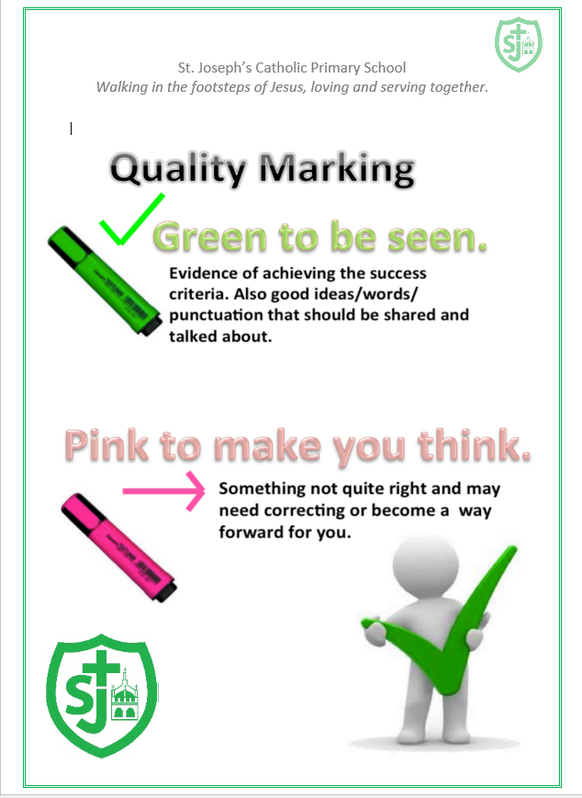

Appendix 3: Feedback and Marking Guidelines
Effective Marking and Feedback

Effective Marking and Feedback | Secure | Mostly | Develop
WALT is clear and specific to the NC – not too broad.
All pieces of work are acknowledged and marked accordingly as set out below.
Any questions or next steps in marking should allow the children opportunity to respond either that day or following lesson, ie, live marking.
When acknowledging learning Highlight examples of key components of the Walt and underline some examples in text.
Green highlight is = good/groovy green, Pink highlighter = Pink to think, next steps
Every piece of work does not need a written comment, however a longer piece of written work produced by a child should have a green comment that celebrates their achievements and a pink comment to outline a next step.
All Written feedback from all staff and work in books should be in our schools handwriting script, ie staff handwriting and WALTs.
Comments should be constructive and positively worded.
Repeated errors must be picked up, acknowledged and give the child opportunity to amend.
Teacher: Year Group: Date:
Observations and Comments

Next Steps

Reviewer: ……………………………………………… Date:……………………

Arrangements for monitoring, evaluation and review

Responsible body for monitoring & evaluation: | Headteacher
Policy reviewed by: | Headteacher
Policy review & approval date: | September 2022
Next review date: | September 2023

