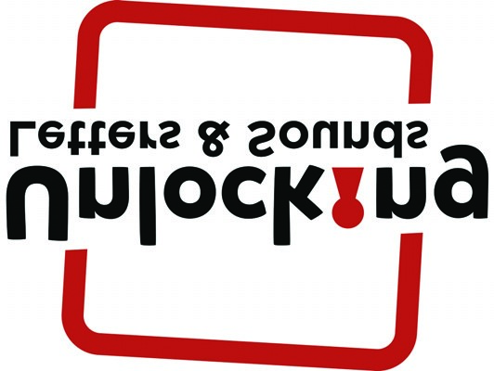
Unlocking Letters and Sounds
Actions, Images and Handwriting – Phase 2
● These are simple, clear actions that don’t impede the child saying the sound
● The sound is only voiced once, so that the teacher can spot those children who are saying the sound slightly behind the rest of the group
● The actions also help warm up hands and fingers, ready for writing
GPC | Image | Action | Lower Case Letter Formation |  | Upper Case Letter Formation
s | 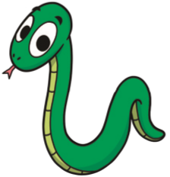 | Snake – Slithering snake action with arm | Up and over, around the other way | s | Up and over, around the other way | S
a | 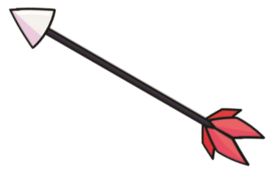 | Arrow – Firing an arrow | Around, up, down and flick | a | Down, down, lift and across | A
t | 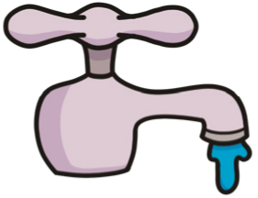 | Tap – Twisting a tap | Down and round, pencil off, across | t | Down from the top, lift  and left to right across the  top | T
p | 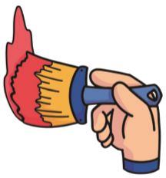 | Paint – Painting with a paintbrush | Down, up to the top, round to the middle | p | Down and back up, around to the middle
P
 |  |  |  | Actions, Images and Handwriting – Phase 2
i | 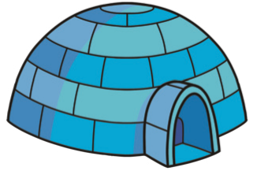 |  | Igloo – Making a curved igloo shape motion with hands | Short down, flick, give it a dot | i | From the top to the bottom, lift, across, across | I
n | 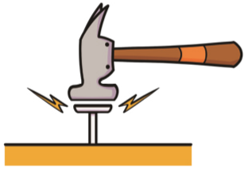 |  | Nail – Hammering a nail | Down, up, over and  flick | n | Straight down and back up, diagonal down and straight  up | N
m | 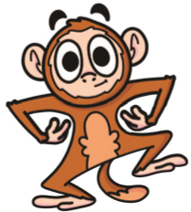 |  | Monkey – Monkey arms | Down, up, over and down. Up, over, down and flick | m | Straight down and back up, diagonal down, diagonal up, straight down | M
d | 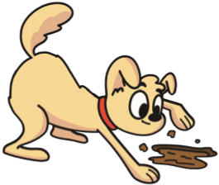 |  | Dog – Digging dog | Around, all the way up, down and flick | d | Down, up, round to the bottom | D
g | 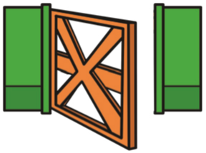 |  | Gate – Closing a gate | Around, up, down and a tail | g | Round from the top, curl along the line, up and down. Lift and across | G
o | 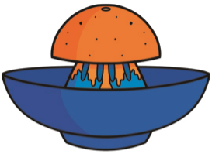 |  | Orange – Squeezing an orange | Around all the way | o | Around all the way | O
c | 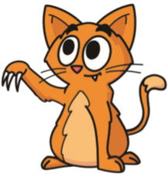 |  | Cat – Clawing cat | Around the curl to sit on the line |  | Around the curl to sit on the line
 |  |  |  | Actions, Images and Handwriting – Phase 2
k | 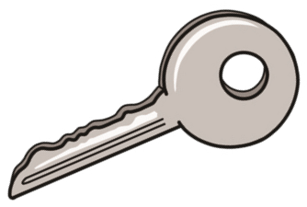 |  | Key – Turning a key in a lock | Down, up to the  middle, loop and  flick | k | Down, lift, diagonal into the middle, diagonal out. | K
ck | 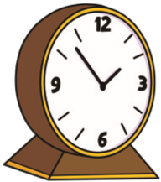 |  | Clock – A ticking clock motion
e | 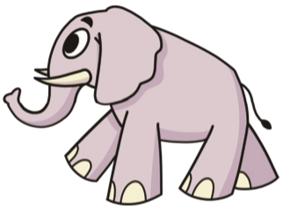 |  | Elephant – Elephant trunk | Across and over, curl to sit on the line | e | Down, back to the top and across, to the middle across, to the bottom across. | E
u | 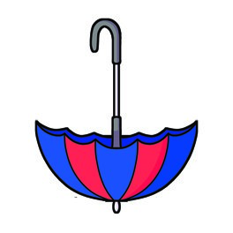 |  | Umbrella – Putting up an umbrella | Down, round, up, down, flick | u | Down, round and up to the top | U
r | 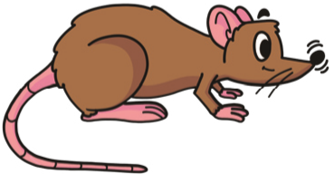 |  | Rat – Make the shape of a rat’s nose | Down, up and over | r | Down and back up, around  to the middle, diagonal  down | R
h |  |  | Hat – Putting a hat on your head | Down, up to the  middle, over and  flick | h | Down, lift, space and down. Across the middle to join | H
b | 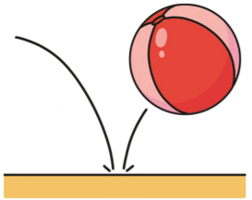 |  | Ball – Bouncing a ball | Down, up to the  middle, round to the  bottom |  | Down, lift, space and down. Across the middle to join

C b B

 |  |  |  | Actions, Images and Handwriting – Phase 2
f | 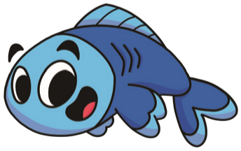 |  | Fish – Hand makes a fish swimming | Over and down, pencil off, across | f | Down, back to the top and across, to the middle across | F
ff | 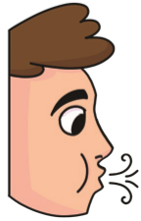 |  | Puff – Puffing out candles
l | 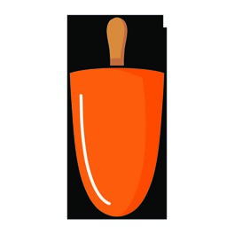 |  | Lollipop – Licking a lollipop | Down and flick | l | From the top, down and across | L
ll | 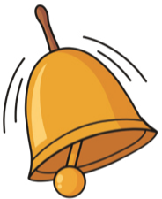 |  | Bell – Ringing a bell
ss | 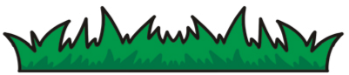 |  | Grass – Grass growing up with fingers

