St. Joseph’s Catholic Primary School, Malmesbury


CORONAVIRUS (COVID 19)

STEP 4 (AUTUMN TERM) - RISK ASSESSMENT

- Assessment No: |  |  | StJCPS/COV19 - 4 (Issue 4)
- Activity/Process: |  |  | CONTAINMENT
Assessment Date: |  |  | Sept 2021
Assessor: |  |  | Brian Birkin-Hewitt (Tech IOSH) School H&SA
Next Review Due: |  |  | As and when required by authority directive
- Number of Persons at Risk: |  |  | Employees Others
 |  |  | 1
 |  |  | 2-5
 |  |  | 6-10
 |  |  | 10 Plus |  |  | x |  | x
4. Hazards:

- Staff member becomes unwell during the school day with Covid-19 symptoms¹
- Child becomes unwell during the school day with suspected Covid-19 symptoms^{2 and 3}
- School advised that a child’s family member has become unwell with suspected Covid-19 symptoms (child in school at the time)

1. E.g., a new continuous cough, high temperature, sore throat, headache, onset of respiratory difficulty, loss of smell and/or taste (anosmia)

2. The first 5 symptoms documented above are relatively easy to recognize in both children and adults. The loss of senses however will only be realised by the affected person and consequently young children cannot be expected to offer this information

3. Children of families with a BAME origin may also display additional symptoms that are similar to toxic-shock: (a sunburn like rash, reddened eyes, nausea and vomiting, diarrhoea, dizziness, fainting, and acute tiredness) as well as abdominal pains and/or gastrointestinal problems

- Proposed procedures/controls:

- Maintain two Isolation Zones, an Isolation Room inside the school, and an outdoor Isolation Area
- Equip both Isolation Zones with ‘Standard’ PPE and sanitization materials
- Remove all non-essential items and/or furniture from the Isolation Zones
- If an Isolation Zone is activated a specific toilet will be assigned for Isolationist use only
- An activated Isolation Zone must not be used again for a period of 72 hours after being vacated
- The Isolation Zone must undergo a ‘Deep Clean’ before being declared as available
- An activated Isolation Zone toilet must not be used again for a period of 72 hours after the Isolation Zone has been vacated
- The Isolation Zone toilet is to undergo a ‘Deep Clean’ before being declared as available
- All used PPE is to be ‘double-bagged’ and held in a safe area for 72 hours before disposal
- Appoint a First Aid qualified staff member to assist where necessary
- Advise NHSTAT if a case of Covid-19 infection is suspected in a Staff Member
- Advise staff members who have been in a ‘Close Contact’ to refer to PHW for further instructions
- Arrange for the urgent collection of a child who is symptomatic; and advise the collecting parent of the revised responsibilities for contacting NHSTAT

- The symptomatic staff member is to:
  - immediately advise other staff and recover to an Isolation Zone with any personal belongings
  - perform a rigorous sanitization protocol, and don the full ‘standard’ PPE
  - arrange transport to home (if necessary, an ‘approved’ taxi service or even an Ambulance may be needed)
  - conduct an LFD home test, and if subsequently necessary
  - arrange a PCR test asap (and remain in Self-isolation until the PCR result is known)
  - follow NHSTAT guidance according to the PCR test result

- The First Aider (a supervising adult) is to be alerted and called to assist; the First Aider is to don full ‘standard’ PPE (see below) before attending to the child

The child is to be taken to an Isolation Zone; personal items are to be ‘bagged-up’ and stay with the child

The child is to carry out a sanitization protocol and don the full ‘standard’ PPE (a Face Visor is not essential); the First Aider may have to assist in both actions

The school is to notify the child’s parents immediately¹ and advise that the child needs to be taken home without delay and undergo a PCR test asap.

The collection point will be at the schools’ main entrance gate

- In the event of BAME child, urgent medical intervention may be needed; if the parent is not readily available to collect the child quickly, consider calling for an Ambulance

- Primary school children who are advised by NHSTAT that they have been identified as a Close Contact with an infected person do not need to be isolated

They are however required to undertake a PCR test asap (arranged by the parent); they should then remain at home until the result of the PCR test is known. The parent should be asked to provide the test result as soon as it known

General Notes:

- In all cases, parents are to be advised if any occurrence significantly affects the schools’ normal daily business (e.g. closure of a class or an extra-curricular club due to unavailable/isolating staff)
- In the cases of a) and b) the affected classroom is to undergo a ‘Deep Clean’ before further use
- All soft material PPE used during the occurrence is to be ‘double-bagged’ and left in a safe area for 72 hours before eventual disposal. Hardware PPE, (e.g. Eye Protection/Face Visors etc.) may be retained, left idle for 72 hours and then subjected to a Deep Clean procedure
- The First Aider should perform a sanitization protocol before and after removing the PPE
- The NHSTAT is to be advised of the instance and for children, the ‘Tracing Journey’ (as promulgated by DfE and PHE, and attached below) is to be followed

Specific Note (iaw WCC (LA) directives - Aug 2021:

If 5 individuals from within the school or 10% of the schools’ total complement are confirmed by NHSTAT as positive Covid-19 cases, within a 10-day period, DfE is to be advised on 0800-046-8687 Option 1. In this instance DfE/PHW may declare an Outbreak and stricter control measures may be re-introduced to facilitate containment

6. The Residual Risk(s) Remaining:  (After implementation of proposed procedures)  - School advised of a Positive Covid-19 instance overnight, child, or staff member |  |  |  | Risk Rating:  Likelihood x Severity = Rating/Action  3 x 2 = 6 Adopt PHE procedures
7. Additional procedures suggested/required:
(Reduce residual risks if practicable to a Risk Rating of 4 or below)

- Parents are to be advised that a child is not to attend school if the child or any member of the home family develops, or is showing signs of, Covid-19 symptoms (see Risk Assessment Covid19-2 Para 7)

- PPE in each ‘PPE EMERGENCY’ box, including those in the Isolation Zones (for patient use) includes:

- Eye Protection/Face Visor
- Oro-Nasal Face Mask
- Apron/Poncho
- Gloves
8. Headteacher Approval:
Date Implemented: 6 Sept 2021  Comments: |  | Procedures Effective: Yes/No
Signed and Appointment: (Headteacher St Joseph’s Primary School)

Name: Mrs Susan Woods
Next Review Date: As determined by an Authority directive that requires changes to the implemented procedures

9. Chair of Governors Awareness:
Date: 6 Sept 2021  Comments: | Procedures Effective: Yes/No
Signed and Appointment: (Chair of Governors St Joseph’s Primary School)

Name: Mr Gregory Fauvarque

RISK RATING |  | RATING ACTION BANDS
LIKELIHOOD | SEVERITY OF HARM | RATING BANDS | ACTION REQUIRED
1. Most unlikely | 1. Minimal | 1 Minimal Risk | Maintain Procedures
2. Unlikely | 2. Requires isolation | 2 - 4 Low Risk | Monitor Procedures
3. Likely | 3. Requires quarantine | 6 - 9 High Risk | Improve Procedures
4. Most Likely | 4. VSI/Fatal | 12 -16 Very High | Revise Procedures - stop all
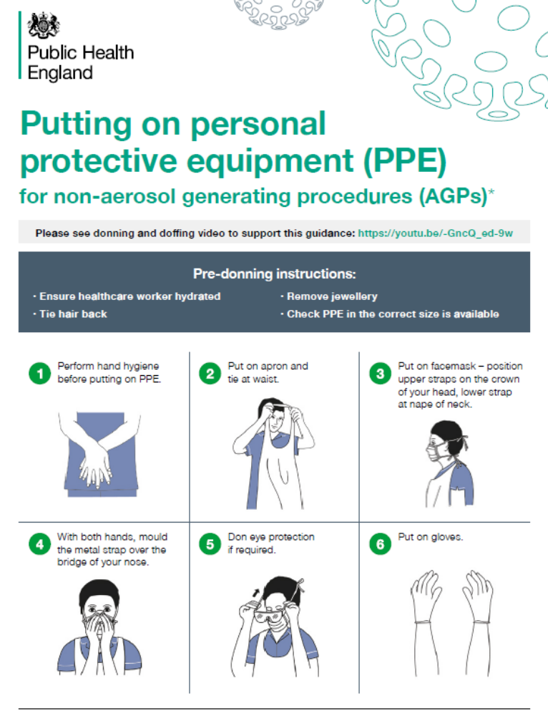

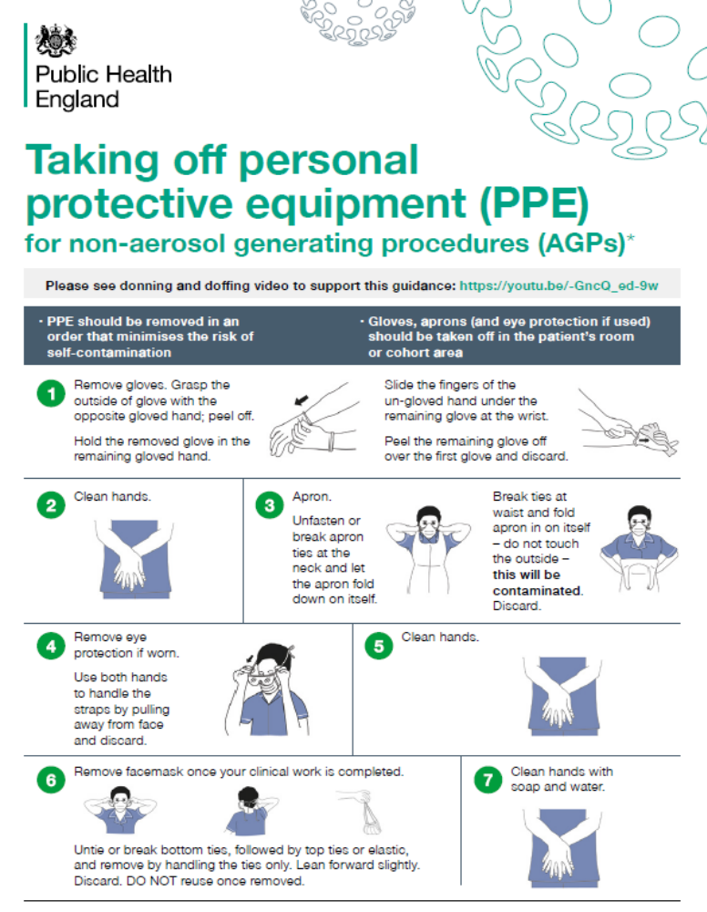

DfE & PHW Operational Guidance: July 2021

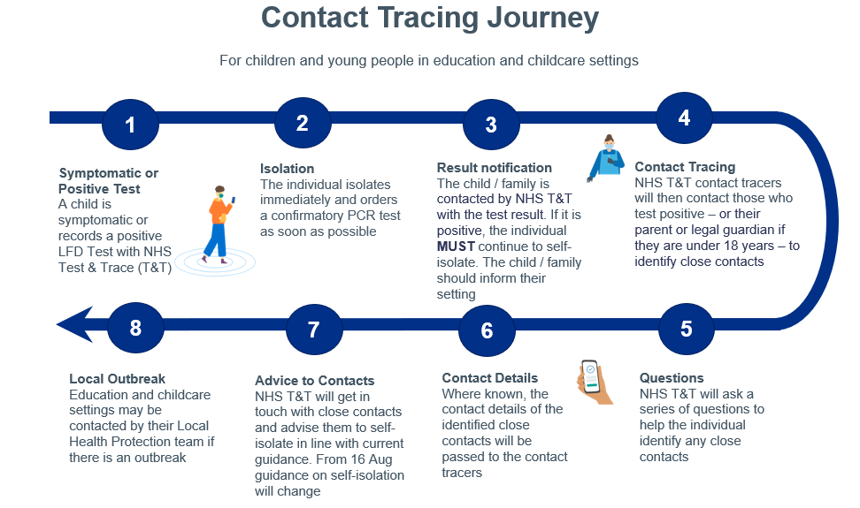

Notes:
- Teachers have a NHSTAT priority
- Schools will be supplied with Polymerase Chain Reaction (PCR) Home Test Kits to be given to staff or parents of children who are being sent home with suspected C19 symptoms and have difficulties in accessing tests elsewhere
- Children who are deemed as CEV should attend school as normal unless advised otherwise by a medical authority
- If the school incurs 5 positive cases of C19 infection, or 10% of the school complement within a 10-day period, PHE/HPT may declare an ‘Outbreak’
- In this instance PHE/HPT will advise the measures to be applied and NHSTAT will alert those who are deemed as ‘Close Contacts’ and are required to Self-Isolate or take a PCR test asap
- The closure of the school will only be implemented in extremis and only if directed by the HPT

Abbreviations used:
CC - Close Contact
CEV - Clinically Extremely Vulnerable
HPT - Health Protection Team
NHSTAT - NHS Test and Trace
PHE - Public Health England (devolved to regional agencies)
C19 - Coronavirus (Covid 19) infection

Definition of ‘Close Contact’:

- Anyone who lives in the same household as someone with Covid-19 symptoms or who has tested positive for Covid-19
- Anyone who has had any of the following types of contact with someone who has tested positive for Covid-19 with a PCR or LFD test:
- face-to-face contact, being coughed on, or a face-to-face conversation within 1 metre
- been within 1m for 1 minute or longer without face-to-face contact
- been within 2m of someone for more than 15 minutes (either as a one instance or total in the one day)
- travelled in the same vehicle or aircraft
- any sexual contact

