St Lawrence – Week 8 Term 6 W/b: 20th July 2020

Final week of the school year and what a year it’s been!!

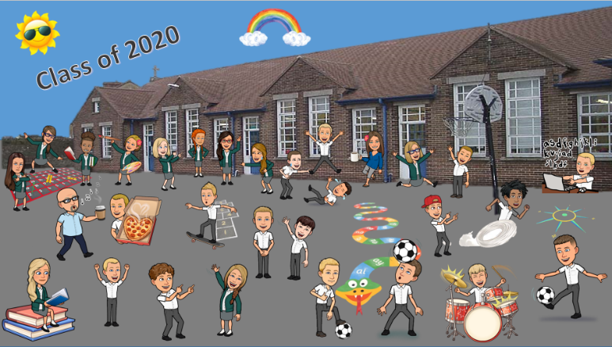

School officially breaks up on Wednesday at 1pm. The White Rose Maths has now finished, so the focus over the next three days will be concentrating on Times Tables.

I would also like you to concentrate on spellings, you know where you’re at this learning the year 2/3/4 spellings so practise writing these out and using them in sentences etc.

Transition class Zoom’s are taking place on Wednesday, the timetable is on the whole school class dojo story. Please try and attend if possible.

Daily Tasks

click pictures below

Class Code : zlu5479

Last week of Joe Wicks!!

Joe Wick is now live three days a week instead of 5. The days that there are live PE fitness lessons are Monday, Wednesday and Saturday. All the previous Joe Wicks sessions are still available online.

PE with Joe Wicks - 9:00am
https://www.youtube.com/channel/UCAxW1XT0iEJo0TYlRfn6rYQ

Jump Start Jonny
https://www.jumpstartjonny.co.uk/free-stuff

English based tasks

Spelling Frame – https://spellingframe.co.uk

Create Year 3 or Year 4 write up book – review the year you’ve had!

I’ve included a Year 3 / 4 spelling activity book in the Drop Box Folder as well.

Maths based tasks

Daily Practice on TT Rockstars: https://play.ttrockstars.com

Times tables worksheets – see Drop Box Folder.

Read a book to an adult for 10 mins daily.

Have a go at exploring the website – Get Epic Class Code : zlu5479

https://www.getepic.com/educators?share=24460092637&utm_source=t2t&utm_medium=link&utm_campaign=rsa_teacher_app

